MUKILAN K

balaji21032002@gmail.com 9344595541



CARRER

OBJECTIVE:

* To excel in the software industry as a top-class professional through hard work and innovative programming strategies.
* 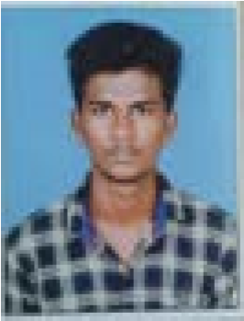To explore new horizons in the field of computer science by acquainting the current technology.



ACADEMIC

QUALIFICATION:

B.E (COMPUTER SCIENCE

ENGINEERING) JEPPIAAR SRR ENGINEERING COLLEGE.

(2019-Present)

CGPA-8.3

HSC State Board of Tamil Nadu

ARLM.MAT.HR.SEC.SCHOOL (2017-2019)

68%

SSLC State Board of Tamil Nadu

Sri Saraswathi Vidhyalaya

.MAT.HR.SEC.SCHOOL(2016-2017)

83%



TECHNICAL

SKILLS:

* Programming Language: C , Python ,Java.
* Databases : SQL.
* Operating system : Windows 7/8/9/10/11, Linux.
* Web Technologies : HTML,CSS.
* Application Packages : MS-Office.



CERTIFICATION:

Completed certification in Machine Learning in python. Completed certification in JAVA development.



AREA

OF

INTEREST:

* Database Management System
* Testing
* Android Development
* Cloud computing
* Webpage Development
* Datastructure



PERSONAL

SKILLS:

* Ability to adapt any Atmosphere.
* Good Speaker and Listener.
* Effective Leadership quality.
* Ability to work with team as well as individual.



ACHIEVEMENTS:

* Completed PARICHAYA HINDI EXAMINATION in First class.
* Completed PRATHAMIC HINDI EXAMINATION in Second class.
* Achieved as a MERIT PARTICIPANT in Stage 1st of State Level Handwriting Competition.
* Participated as a JRC volunteer of sri saraswathi vidhyalaya matriculation hr.sec.school. in the

EDUCATIONAL DISTRICT LEVEL CAMP.

* Participated in Mammoth Chess Record Attempt,DISTRICT LEVEL MEGA CHESS TOURNAMENT.  Achieved 3rd position in 10th CUDDALORE DISTRICT YOGA OPEN CHAMPIONSHIP-2015.



HOBBIES:

* Playing Games.
* Listening Music.
* Cooking.
* Reading Books.
* Travelling.



PERSONAL

DETAILS:

|  |  |  |
| --- | --- | --- |
|  | Date of Birth | : 21/03/2002 |
|  | Father’s Name | : B.KUMARASAMY. |
|  | Gender | : MALE. |
|  | Languages Known | : Tamil , English,. |
|  | Current Location | : Chennai. |
|  | Address | : No.3 Naidu Street, |

Puddhukupam annavali post , cuddalore tk.



DECLARATION:

I hereby that the information furnished above is true to the best of my knowledge and belief.

PLACE : CHENNAI

DATE: 